**Required Files:**

**assign_expressions.py**

The Python file which you will write your relational algebra expressions and submit to GradeScope.

**Assignment_3_autograder.ipynb**

The JupyterNotebook where you will test your expressions based on a sample database.

**sample220.db**

The sample database file.

**requirements.txt**

Required packages to install.

**How to use the autograder?**

Step 1:

Open the Assignment_3_autograder.ipynb file on google colab

<https://colab.research.google.com/>

Step 2:

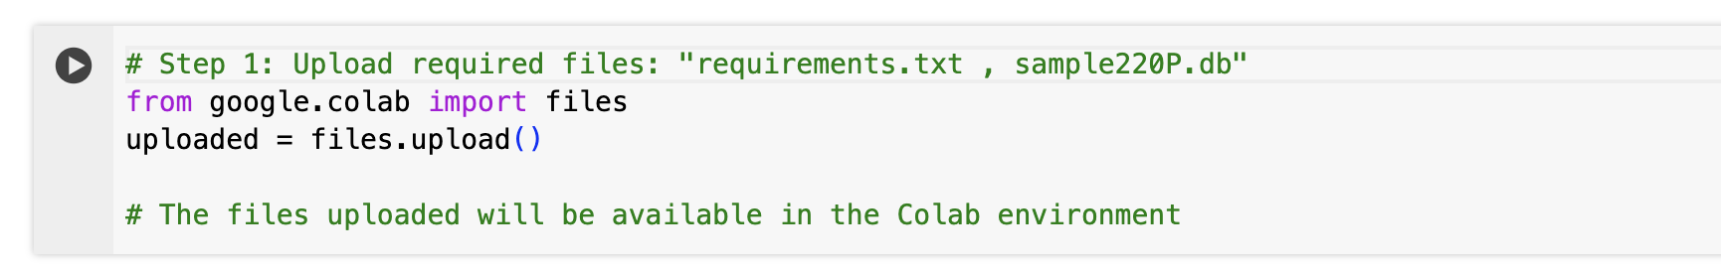  
Run this code shell and upload ‘sample220.db’ and ‘requirements.txt’.

Step 3:  
Run the rest of the code cells. ##Do not modify the script##

Step 4:

Examine your test result according to the last cell output.

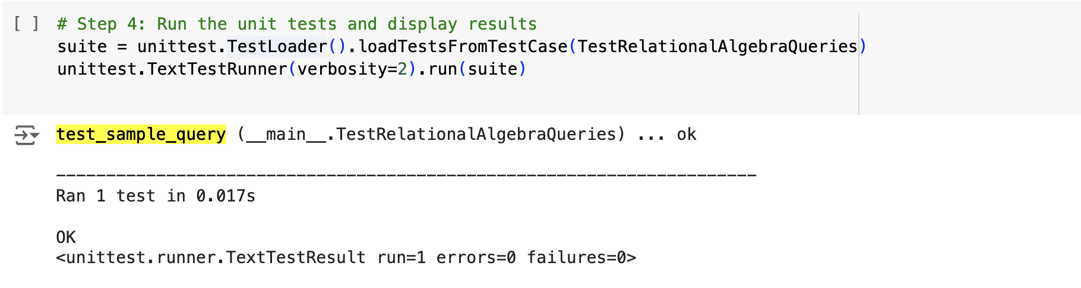

If all tests are ‘OK’, you pass the sample test.

Note: The sample db is just a small portion of the real test on GradeScope. Passing sample tests does not ensure you pass all tests on GradeScope.

Step 5:

Submit your **assign_expressions.py** on GradeScope.